Tactile display for the visually impaired using TeslaTouch

Visually Impaired TeslaTouch

【Main Content】：

Research on Tactile Feedback for People with Visual Impairment.

【Experiments】：

Apparatus：

TeslaTouch

**Dots:** A dot is rendered as a linear change of signal amplitude, arriving at its maximum at the position of the dot (Figure 4). Participants started by feeling a row of dots. As the signal is directly coupled with figure location, users engage in an active touch, an intuitive and effective way of exploration. After two or three minutes adjusting to the sense, participants recognized the dots and described them as a “slight change of friction”, “sticky” spots, or “chalk board”.

**Braille Letters:** The six dots in a standard raised braille cell can be felt simultaneously under one fingertip (Figure 5). Since TeslaTouch renders the same sensation for the entire contact area, the dots are not distinguishable in the same way. We experimented with three strategies of mapping braille to tactile sensation.

1. FREQUENCY MODULATION

Each dot is mapped to a distinct frequency, and dots in the same column are played at the same time. Unlike ears, the human skin proved to be poor at identifying multiple simultaneous frequencies.

1. TEMPORAL MAPPING

Dots one through six are played in sequence as the finger moves along, with short pauses between dots, and longer pause between characters. Nokia Beta Labs took a similar approach using cellphone vibration [1]. When it was demonstrated to our participants, though, one commented that this requires “a lot of effort”, and may not be practical.

1. SPATIAL SEPARATION

We enlarged the distance between dots in a braille cell to be slightly bigger than a fingertip. Within the given 2 minutes, no participant could recognize a letter. In discussion we identified the following issues.

**Images:** The visually impaired could potentially use TeslaTouch to share photos in a family setting, or view whiteboard in a classroom setting. To understand how to best represent images on TeslaTouch, we started with three simple geometric shapes- circle, square, and triangle- and asked participants to feel and identify them. Each shape was 5 cm in width and height, and was rendered in three styles: outline, solid, and solid with outline (Figure 6), totaling nine. One image was displayed each time.

**Tactile Drawing：**2D rendering can be linked in the 3D plane.

Discussion: Our initial testing of blind volunteers showed great interest in creating and displaying visual information using TeslaTouch.

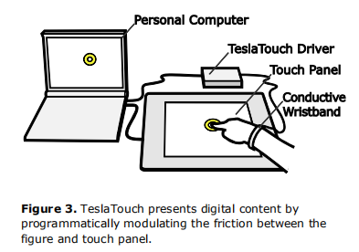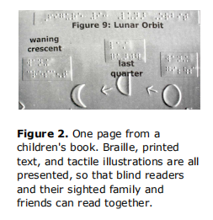

【Several research directions in the future】：(Detail in paper)

Tactile Rendering Palettes

Tactile Icons

Navigation on TeslaTouch

Dynamic Information Display

Other complementary sensations

【Subjective analysis】：

**Advantage:**

This article compares haptic screens with printed Braille, and attempts to simulate Braille in three ways.

**Disadvantages:**

(1) But it is not inherently suitable for personal use because it requires the user to connect via a wristband and the device needs to be connected to a personal computer.

(2) None of the three ways to simulate Braille can be a good substitute for real Braille.

